STAPLE DIET
No. 113 APRIL 2019
(The West Quantoxhead Village Newsletter)
Editor – Duncan Stafford email SeaFurlong@aol.com
email SeaFurlong@aol.com

Rector: Revd. Nicky Morgan 01278 732873
Associate Vicar: Revd. Dr Andrew Tatham 01984 633331

ST ETHELDREDA’S CHURCH SERVICES
31st March Mothering Sunday Benefice Service at St.Etheldreda's at 10am
7th April 9.30am Eucharist with PC
14th April 9.30am Eucharist with AFT.
EASTER DAY
21st April 9.30am Easter Eucharist with NM
28th April 10.00am Benefice Eucharist at KILVE COURT followed by the combined APCM*.

OTHER EASTER SERVICES
7.00pm Saturday 20th April at East Quantoxhead
SUNDAY 21st APRIL
5.30am Sunrise Service at STOLFORD BEACH (TA5 1TW)
or OS ref ST233459
9.00am Eucharist at FIDDINGTON with AFT
9.30am Eucharist at KILVE with DB
10.30am Eucharist at STOGURSEY with TS
11.00 am Easter Praise at HOLFORD with SC
4.00pm Easter Garden at STRINGSTON with NM/SB

LENT LUNCH
This year, the joint East and West Quantoxhead Lent Lunch will be held at the St.Audries Village Hall on April 11th between Noon and 2pm

*THE ANNUAL PAROCHIAL CHURCH MEETING
Will be held at the Outdoor Centre, Kilve Court on Sunday 28th April;
!0 am Benefice Eucharist
11am Coffee
11.30am APCMs held jointly
12.15pm Presentation by guest Speakers
1.00 pm Hot Pot Lunch

ST AUDRIES W.I.
The next Meeting will be on April 10th in the Village Hall. The talk will be at 2.15 pm with the business meeting afterwards.
Speaker - Ian Caskie - " S.S. Great Britain ".
Competition an item in yellow.
All Visitors Welcome.

CRAFT GROUP
Come and learn/share new craft skills. We meet every Tuesday in the village hall 2pm to 4.30pm (except Tuesday 23rd April).

ST AUDRIES ART GROUP
St Audries Art Group meets in the Village Hall on Wednesday mornings from 10am until 12.30pm. If you are interested in joining us or just popping in to see what we do, please contact Pat or Maureen on 632729 or 632575.
ANNUAL PARISH ASSEMBLY
All parishioners are invited to attend the Annual Parish Assembly Meeting on Wednesday 3rd April at 7-30pm at the St.Audries Village Hall.
Speakers will be: Association of Blood Bikers, Cllr Chris Morgan who will speak about HPC, Mr James \Hassett CEO of the new Somerset West and Taunton Council.

FEBRUARY’S WEATHER
Very much a jam sandwich. Snow and rain early in the month and again damping at the end.
5cm Snow
59mm Rain
Most Rain 37mm 9th February
Snow 5cm 1st & 2nd February
Sunshine 21 days more than 1 hr
Highest Gust 42 knots 8th February
Coldest Temperature - 2.8c 2nd February
Highest Temperature + 18.3c 25th February

WINDMILL LOCALS LUNCHES
As usual the monthly Locals Lunch will be held on the second Thursday of the month so the next one will be on 11th April. Arrangements are 12.30pm for 1.00pm for two courses at £10 per person with an option for tea or coffee to follow at extra cost. Please let Tony know a few days in advance on 633004 if you intend to come.

POETRY GROUP
We will meet at Daphne Wheeler's house, Ferndal, The Avenue, on Thursday 25th April from 2.30 pm - reading poems about Trees and Flowers. New readers welcome. For more information telephone Joyce Baxter 633537.

PILATES
Held at West Quantoxhead Village Hall on Thursday morning and Tuesday evening. For further details, please call Nathan on 07762 721 271 or email nathanpirt@iCloud.com.

OTHER LOCAL EVENTS
Italian Dinner at Fiddington Village Hall on Saturday 30 March 6.30 for 7pm £15.00pp
The monthly EQ Market will be held at the East Quantoxhead Village Hall on Saturday 20th April between 10am and noon.
Cleverly Everlies at The St.Audries Bay Holiday Club Saturday 27 April 7.30pm 01984 632515/01278 652059

THE PROBUS CLUB OF THE QUANTOCKS
The Probus Club meets Tuesdays at the 'Windmill Inn' 10.30am for coffee and interesting talks on many subjects. On the second Tuesday of each month we meet later for a lunch meeting with wives/partners. New Members and Visitors always welcome. Information 633060 or 632653

TABLE TENNIS COFFEE MORNING
On Saturday, April 6th, between 10.00am and 12.30pm there will be a Coffee Morning in the Village Hall with the opportunity to “have a go” at table tennis, re-hone latent skills, or just pop down for a chat, a tea or coffee and cake. A chance for all members of the village to get neighbourly Don’t be shy - we don’t bite!
For further information contact Sue Sanders on 632759.

DISCOVERIES SINCE THE BOOK OF ST.AUDRIES
Following my imaginary meeting in 1817 with William and Jane Cross at Selcombe’s Cottage (The site of the later Church Lodge). A letter arrived from Australia barely six weeks after the book’s publication in 2006. The letter was from a descendant of theirs living in Flinders Lane, Melborne. She had found the book on Amazon and discovered my reference to her great, great, great, great grandparents. Her letter informed me that their grandson and her great, great grandfather Charles Cross, son of Robert, emigrated in c1850. Correspondence ensued and subsequently a remarkable family history soon emerged. William and Jane’s son Robert married Mary Willcox on 26 December 1819 and had seven children; Lena 1821, James 1823, Louisa 1825, Elizabeth 1827, Jane 1830, Charles 1832, and Charlotte 1834.
William and Jane’s grandson Charles was born in 1831/2, the 1841 census states his age as nine. Some seven years later he obtained an assisted passage and emigrated to Australia aboard the ‘Emperor.’ He landed at Botany Bay when aged 16 on 4th November 1848 and was soon involved in the gold rush where he met and six years later married Harriet Wilbur a widowed nurse from Yorkshire on 16th December 1854 in Maryborough. They headed south and settled first as pioneer farmers in Yackandandah (now at the bottom of a lake formed by the Dartmouth Dam in 1970) and later in Tallangatta. They raised a family and he was buried at Yabba aged 61 on 2nd April 1895.
Research both here and in Australia, revealed the Cross family had lived in St. Audries for at least 320 years from 24th October 1558 when John Chedzey and Elizabeth Cross was married, (the third recorded marriage in the Parish Registers) and until 3rd August 1879 when Mary Cross aged 85 was buried. There are about 120 references in the registers and about 40 in the ‘Poor Book’. The family fell on hard times between 1800 and 1811 and received many contributions from the Overseers when in need, in sickness or in need of clothing. It seems probable that another Jane Cross moved to Watchet to assist her family and once received three shillings to buy bread. After 1811 she obtained employment presumably at the poor house at a shilling a week for a few years.
Parish records and a detailed map dated 1817 enabled me to imagine myself walking around the parish at that time. I stopped and spoke to Jane Cross the wife of William Cross who had lived in one of Selcombe’s cottages on the site of today’s Church Lodge. Jane died in 1827 aged 75 and William in 1838 aged 83.
My correspondent had just discovered her ancestors originated from St.Audries purchased the book! She was just hoping to learn something of the parish. Just imagine her delight and surprise of actually finding mention of her family.
Subsequently we were in regular communication and a remarkable story has unfolded through the continuing research. At the time of writing the book it had occurred that it seemed odd that the couple’s grand-children seemed to have vanished – until it emerged that they emigrated in 1848!
The records show how the family’s status in the village had waxed and waned during the centuries from Church Wardens to the Poor House in the 19th century.
James who we recently discovered emigrated earlier, died aged 32 and was buried in Yakandandah in 1855.
Louisa, Elizabeth, Jane and Charles landed in Botany Bay after a 102 day voyage on the ‘Emperor’ on November 4th 1848.
It is likely that both Louisa and Elizabeth married and lived in Sydney/QC but are still to be traced.
Their sister, Jane it seems didn't settle and soon returned to the UK but later re-emigrated this time to Hobart, Tasmania with her youngest sister Charlotte. There after a period of domestic service Jane married John Clarke and together they took the licence of the Railway Hotel, now The Racecourse Inn in Marlborough Street, Longford and raised their family.
Their descendents have met up with their cousins in Melbourne as a result of this research.
Much later I discovered that the young family were escorted to Australia in 1848 by the Porter family who lived at Shore Edge. Both families have recorded their recent visits to our Church. Sadly I didn't meet them.

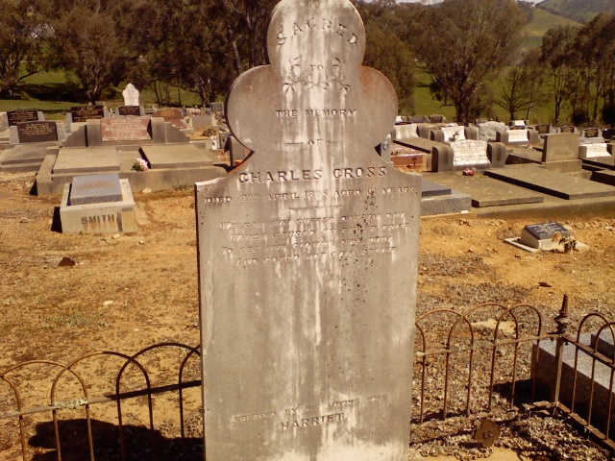

Grave of Charles Cross at Yabba

Copy date for May’s newsletter is 20th April . (Please mark for “Staple Diet” or “Newsletter”). Phone 01984 632268 or email: SeaFurlong@aol.com

